Brooklyn Outdoor Film Festival

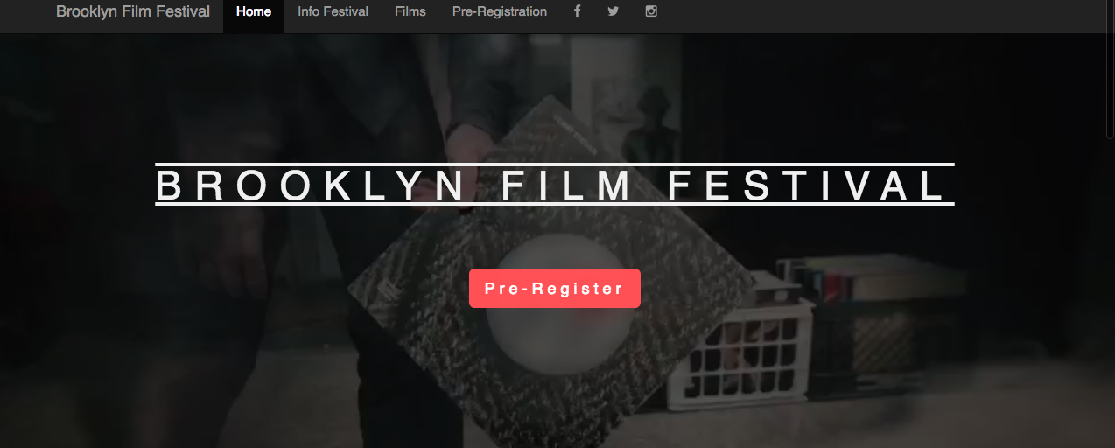

Summary page 2
Stakeholders page 2
Budget page 3
Goals page 3
Timeline page 4

SUMMARY

Brooklyn Outdoor Film Festival just got approval to show movies at Brooklyn Bridge Park. Jennifer needs a fresh website to promote the festival. Shows will be free and open to everyone but customers must reserve their seats online.

STAKEHOLDERS

In this project will be involved:

- Marc from the design team to ensure that images and videos are running smoothly;
- Erik and Katerina from the finance department to ensure the budgets are respected;
- Ethan, Product Manager
- Developers:

  - Myself, front-end developer
  - Malika, lead designer, to support developers

BUDGET

Total budget of $3,500.00

BUDGET ITEM | BUDGET USD | TOTAL
Design team | $600.00 | $600.00
Finance Department | $600.00 | $600.00
Developers | $1,800.00 | $1,800.00
Travel | $500.00 | $500.00
TOTAL | $3,500.00 | $3,500.00


GOALS

This project would have:

- Pre-register tickets sold out for the weekend by Thursday the 5th.
- At least 50% of pre-registration on the day of the launch of the website

TIMELINE

The project should take maximum 7 weeks:

- First week visit at Brooklyn Park and community;
- Second week finalize Strategic Plan;
- Third week start coding and editing videos and images;
- Fifth week meeting;
- Sixth week start final stage.
- Seventh week launch website


